## Partner contact info

Organization: Erste Yazılım

Type: Industry/SME/Research/Academia

Name: Özer Aydemir

E-mail: ozer@iotiq.de

Phone #:

## Partner interests within the project

<Please provide a short description of your R&D and collaboration interests and expectations within the OWE4SC project>

Erste, established in Cyberpark Bilkent , Ankara in 2007 , is R&D based multinational SME collaborated with corporates and companies( Bosch, Siemens, Koç sistem etc. ) .Our mainly focuses are IOT technologies and advancements ,video streaming and analysis as well as mobile applications and framework development. We also bid for state-of-the-art software development projects our purpose is mainly to offer a good quality end to end services for our customers and partners. Our projects got awarded several times by respective committees for instance TUBİTAK, KOSGEB and ITEA etc... We use the latest and most advanced technologies (such as JavaScript, NodeJS, ExpressJS, MongoDB, Wowza etc... ) to satisfy our clients’ expectations from diversified domains (such as Supply chain, Infrastructure, Health, Energy etc.) and to increase our quality of services. We actively participate in Cluster programs such as ITEA3, EUREKA etc. including innovative, industry driven and pre-competitive R&D projects with the purpose of gaining know-how and reinforcing our skills. Our goal in this project to develop AI powered open-source and collaborative IOT platform integrated with edge computing technologies targeting smart building and communities.

## Open Data and Technologies

We have an ongoing projects like Gamma, Optimum, Baas developed for smart building and communities as well as commercialized product,Mobivisor , linked to OWE4SC.

**Gamma** , is a collaborative and enriched open source modelling platform creating secure, reliable, healthy and comfortable environment for our client , incorporating heterogeneous network and devices(such as HVAC, electricity and water etc.). Initially, Gamma consists of data, data points, features, device services(door sensors, temperature/humidity/pressure sensors, blind controller, wall plug and orchestrator services ) and communication services(wave and zigbee) entities to define sensors properties and functionalities on the smart building and environment and establish communication protocol between them. As an additional feature, BEY (building and floor modelling and visualization tool) is embedded as plug in Gamma. BEY helps customer create 2d building and floor modelling, supervisioning and visualization to determine optimal location for devices and sensors to be mounted. Our project relies on distributed control platform providing device to device communication instead of centralized control management and governance with the aim of energy consumption minimization and operational cost reduction. It also mitigates the risks of cyber-attacks, fraud and outages in a reliable, secure and interoperable and loosely coupled way. Link given below describes project details and description.

<http://gammaf.herokuapp.com/#/>

**Mobivisor,** a profile and policy based mobile device and application management system, enables data and record collections, dynamic reporting, multi user and device support, comprehensive documentation and LDAP user name and password creation, multi language support , encrypted VOIP with enriched and leveraged security features. For corporates, this application provides mobile content management sharing with employees and allowing to access their contents, real time reports indicating power consumption, battery usage RAM and CPU usage, restriction on phone usage capabilities, setting and applying set of rules against mobile violations, corporate data safety integrated with LDAP encrypted by SSL/ TLS protocols and location tracking

More details can be found in the following link:

https://mobivisor-mdm.com/en/mobivisor-mdm-mobile-device-management-why-mobivisor.html

**https://mobivisor-mdm.com/en/doc/combined.html**

## Success Factors/KPIs

<Please describe when you would see the project has been a success for you. Please identify and list relevant KPIs (Key Performance Indicators) from your organizations viewpoint.>

* Accuracy and precision of methodologies and algorithm (To be specified after SotA analysis).
* The minimization of network faults (latency and low-bandwith problems etc. The details will be shared after SotA analysis)
* Establishing reliable and quick communication among devices in real time (To be specified after SotA analysis a). (To be specified after SotA analysis).
* Fast and reliable system recovery and back-up without human based operation (measurement will be decided after SotA analysis).

## Background

Please list previous R&D projects you see relevant regarding OWE4SC project as background/collaboration possibility:

|  |  |  |  |  |
| --- | --- | --- | --- | --- |
| Project Name | Cooperative Programme | Time period (approx.) | Technical Focus | Relationship |
| <BaaS > | <ITEA3> | <2012> | < The main basis of Baas is technological production focused on smart buildings and smart environment with IOT technologies. Within this project,  Baas aims to build integrated services on the environment to eliminate time or operation related problems and risks. All objects and devices in the place thus sensors, actuators and device) s can communicate each other more seamlessly, secure and feasible wıthout interruption. 2D environment envıronment and building modelling, layering and commissioning are one of the features adding the values in the system architecture and framework platform  > | Some features of Baas can be extended and used in the  OWE4S in case of Machine to machine communication, virtual and physical devices creation, device and sensors localization and assembling them in optimised places in the building, 2D building and environment modelling and visualization.  This system gives self autonomous control instead of centralized management. This system works in the principle of loosely coupled architecture enabling isolated work space for each system without halting other system functionalities. |
| Optimum | ITEA | 10.2017-- | Within OPTIMUM project, we'll help the consortium to build an IoT platform for implementing Industry 4.0 to the material handling means.  Optimum technical focus is  IOT based open-source and distributed platform providing machine to machine communication by eliminating manual operations complexity  All cranes in the system will have their self-control mechanism and exchange their information and data based on distributed control application  This open source platform enriched with context-awareness methodologies and localization system architecture.  Established service communication and integration via HMI(human machine interfaces)  3D-based engineering, virtual commissioning and supervision based on common models is also included. | OPTIMUM might be directly linked to OWE4S with respect to entities mentioned below  Replacing centralized control of manufacturing and material handling components by intelligent components based on distributed control software(even on the sensors),  Enhancing control SW of material handling components with context awareness,  Replacement of HW diversity by SW modularity,  Design of an open platform supporting interoperability with third-party control and application software,  Increasing safety, performance and flexibility based on context/ awareness and secure communication between distributed control modules,  3D-based engineering, virtual commissioning and supervision based on common models. |

Please indicate any relevant publications (scientific papers, white papers, etc), which you see relevant for the OWE4SC project as background information:

* Medagliani, Paolo & Leguay, Jeremie & Duda, A & Rousseau, Franck & Duquennoy, Simon & Raza, Shahid & Ferrari, Gianluigi & Gonizzi, Pietro & Cirani, Simone & Veltri, L & Montón, Màrius & Domingo Prieto, Marc & Dohler, M & Villajosana, I & Dupont, O. (2014). Internet of Things Applications - From Research and Innovation to Market Deployment.
* Muhammad Rizwan Anawar , 1 Shangguang Wang , 1 Muhammad Azam Zia,2 Ahmer Khan Jadoon,1 Umair Akram,3 and Salman Raza1 Fog Computing: An Overview of Big IoT Data Analytics

Please indicate any relevant market study you see relevant for the OWE4SC project objectives:

* [https://www.mckinsey.com/~/media/mckinsey/industries/capital%20projects%20and%20infrastructure/our%20insights/voices%20on%20infrastructure%20turning%20the%20smart%20city%20opportunity%20into%20reality/voices-december-2017-web.ashx](https://www.mckinsey.com/~/media/mckinsey/industries/capital%20projects%20and%20infrastructure/our%20insights/voices%20on%20infrastructure%20turning%20the%20smart%20city%20opportunity%20into%20reality/voices-december-2017-web.ashx%20)
* <https://ww2.frost.com/files/8715/1248/3558/SmartCities_-_Nov_2017.pdf>
* <https://www.forbes.com/sites/bernardmarr/2018/01/28/blockchain-and-the-internet-of-things-4-important-benefits-of-combining-these-two-mega-trends/#4c074dfd19e7>
* https://www.buildingtechnologies.siemens.com/bt/global/en/building-solutions/bps/strategy-planning/advantage-navigator/Pages/advantage-navigator.aspx

## Collaboration

<Please describe what kind of collaboration and networking benefits and added value your organization is looking for by participating the project. Please consider both business and technological viewpoint.>

Outputs<Please describe outputs (novel algorithms, standards, open source libraries, implemented collaborative framework, demonstrator, product prototype, new service based on some software, wearable device, etc.) that you organization can create/contribute to during the project.

* Unsupervised learning methodologies
* Semi –supervised learning techniques
* Distributed control platforms(M2M communication) (GAMMA)
* Creating analytical and statistical based dashboards
* 2D or 3D modelling supervisioning and commissioning platform(BEY application)
* Smart environment based platforms
* Distributed control platform
* Mobile device management based systems
* Video and media streaming , capturing based systems
* DOME(Distributed object modelling environment)
* Security frameworks and application STRIDE analysis
* Open source based mobile applications (MOBIVISOR)
* Engineering tools for enhanced smart evironments
* Introducing Zigbee and Zwave protocols to services (GAMMA)
* Creation data, data points,features,services,systems to interconnect devices and sensors(GAMMA)

## Role of the partner

## Through OWE4SC project lifecycle first we can support requirement analysis and elicitation phase which directly links to WP1 (Digital Services, Use Cases, Requirements and Business Models) related tasks. We can discuss stakeholder and end users and anticipate their functional and non-functional requirement aligned with their business models and lifecycles. With our deep know-how and extensive expertise, we would like to act on the tasks concerning edge computing technologies, Internet of Things (IoT) development and digital infrastructure construction that will be executed under work package(WP4 Edge Computing, IoT and Digital Infrastructure). We can participate in proof of concepts studies and develop demonstrator over the top of application and frameworks to test their eligbilities and performances tied to digital marketing services.

## Innovations and Standards

<Please list any relevant innovations and standards regarding the project from you organization perspective. Please identify any relevant standardization organizations that your organization is participating.>

## Value chain positioning

<Please describe positioning of your organization in socio-cyber-physical value stream and markets illustrated in Figure 1 below>

**Relevant markets of the socio-cyber-physical value stream for my organization:**

Our organization actively participate in IOT based project and some of them (Gamma and Mobivisor and Bey) have already commercialized. Along these projects mentioned before, we gained insight and perspective about how new technologies and methodologies can be applied for diverse a wide range of domain(smart energy, environment, supply chain) .Generally , we mainly focused on the following areas edge computing technologies and systems, application and frameworks development, video and media streaming, brokerage, image processing, mobile applications and APIs and security frameworks. Within given context, our market position can be placed in:

* Edge Computing Markets
* Autonomic system markets
* Professional mobile apps and services markets

**Positioning in the socio-cyber-physical value stream:**

<Please describe the added value your organization can bring within the value stream. What kind of organizations you envision as customers for your offering and on which markets? Which markets you need to participate and what kind of organizations you need to co-operate with to be able to provide your envisioned offering?>

Since the beginning of April 2018, World Bank allocated $91.54 million budget for the Sustainable Cities II Project in Turkey. With this funding, economic, societal, financial and environmental condition will be strengthened by providing enhanced services to municipalities in the cities. First, a part of the budget was spent on construction renewal, water and wastewater systems. Also, semi government companies like Turk Telekom and Innova has broadband fiber infrastructure in every city in Turkey, it could act as an integrator for U.S. companies while reaching out to Turkish municipalities.

With technological advancement and increase in people demand and interest, the market share of smart environment has grown especially among construction companies. According to given surveys in Turkey, using smart technologies in municipalities has been increased by 47%. In global era, at least 80% of construction will include at least one IOT based technologies. According to given results, global IOT smart building market will reach 51,44B$ globally by 2023. At least 33% of buildings and constructions will be advanced with AI based technologies. 5G and real time data analytics accompanied with IOT will play major roles in smart building systems.

All the information and background information mentioned above shows which markets we involve are IOT companies, smart building companies, telecom infrastructure supplies, cloud services and management. Our solution also addresses the divisions mentioned below:

* Smart Buildings Manufacturers
* Smart Buildings Distributors/Traders/Wholesalers
* Smart Buildings Subcomponent Manufacturers
* Industry Association
* Downstream Vendors

Using smart technologies in the cities and buildings contributes to economic growth and social impact in terms of the subjects mentioned below:

1. The global business network will be extended. Our production can motivate other groups to carry out more research and development based projects. Municipalities can be motivated to allocate more budgets on smart technologies and IOT based applications.
2. The interest rate of people working in construction and trading companies can increase against AI- and machine learning based systems.
3. Adding smart features in buildings will make people’s life easier and comfortable, as well as the security and safety in the environment can be ensured leading to increase their life span.

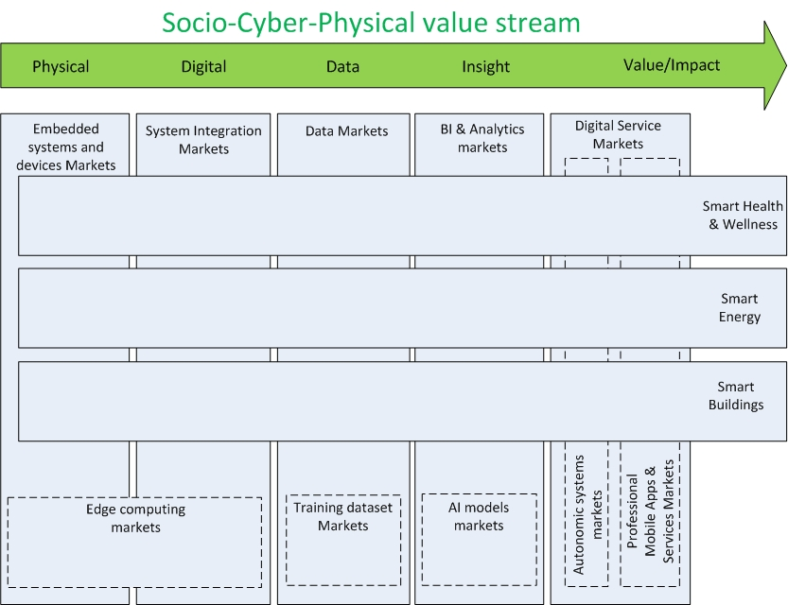

**Figure 1. Socio-Cyber-Physical value stream, related markets and application**

**N domains**.